**INSTALL WINDOWS 10 USING**

**A BOOTABLE USB DRIVE**

**AND RUFUS**

**LAB # 02**



**Fall 2021**

**CSE101L Computer Fundamentals Lab**

Submitted by: **Ali Asghar**

Registration No. : 21PWCSE2059

Class Section: **C**

“On my honor, as student of University of Engineering and Technology, I have neither given nor received unauthorized assistance on this academic work.”



Student Signature: ______________

Submitted to:

**Engr. Abdullah Hamid**

November 29, 2021

Department of Computer Systems Engineering

University of Engineering and Technology, Peshawar

**Q 1: How to install windows 10 using .iso file and bootable flash drive?**

**Ans:** In order to make a bootable device, we need a flash drive having minimum of 8 GB space and a Software named Rufus.

Rufus can be downloaded from this link.

https://rufus.ie/en/

**STEP 1: Download .iso(Image) File from Internet.**

Windows 10 iso file can be downloaded from this link.

https://www.microsoft.com/en-us/software-download/windows10ISO

**STEP 2: Make a bootable USB using Rufus Software.**

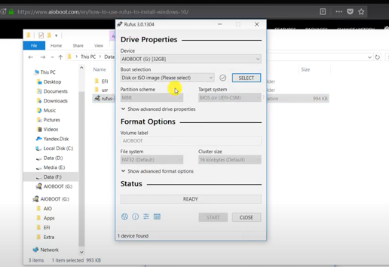

i)Open Rufus, the above window will appear

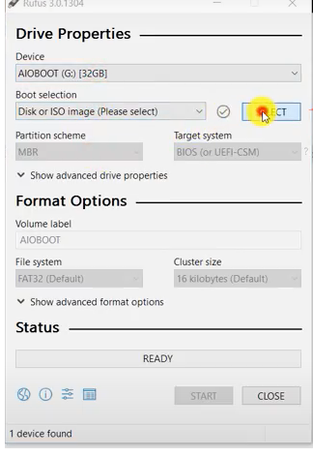

ii)Left Click on Select Button to select an iso file.

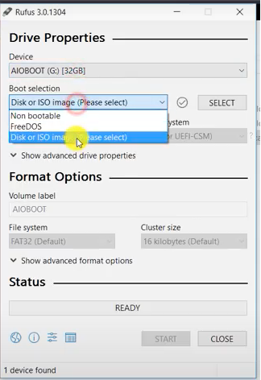

iii) Select Disk or ISO Image option.

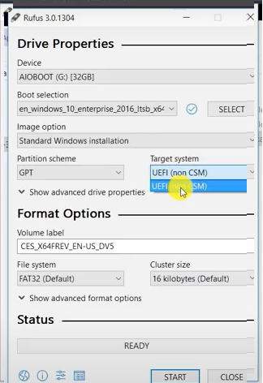

iv)For UEFI, Select

Partition Scheme : GPT

Target System: UEFI(Non CSM)

File System: FAT32

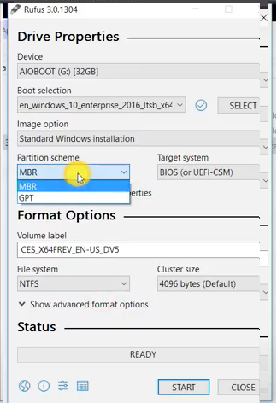

v)For BIOS Legacy, Select

Partition Scheme : MBR

Target System: BIOS(or UEFI CSM)

File System: NTFS

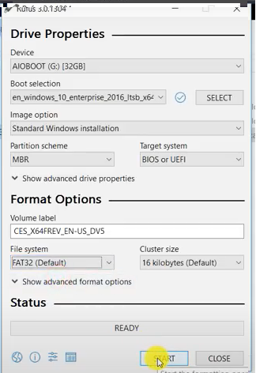

vi) Click Start to make it a bootable usb with the windows .iso file

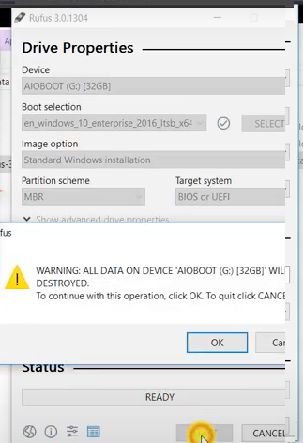

vii)Click OK to continue.

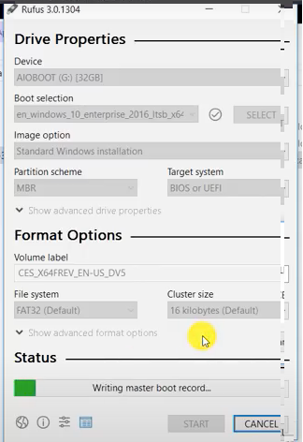

Wait for the progress to complete.

**STEP 3: Restart the computer and install windows 10.**



i) Press f2 and Set the USB as bootable device in UEFI/BIOS.

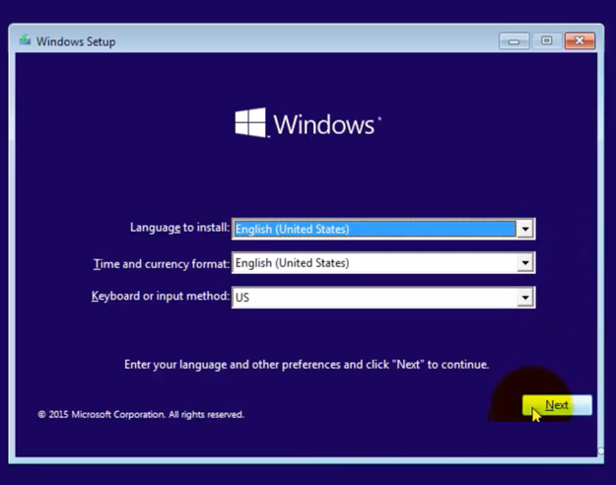

ii) Select Language, Time and Currency format and Keyboard or Input Method.

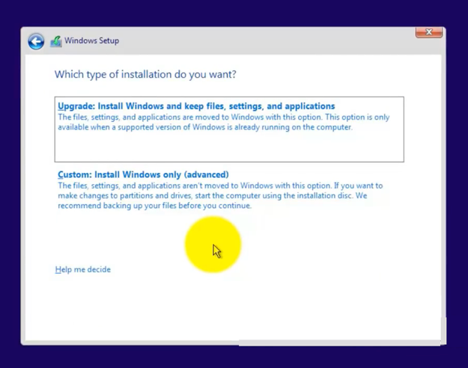

iii) Select the installation type as per your preference.

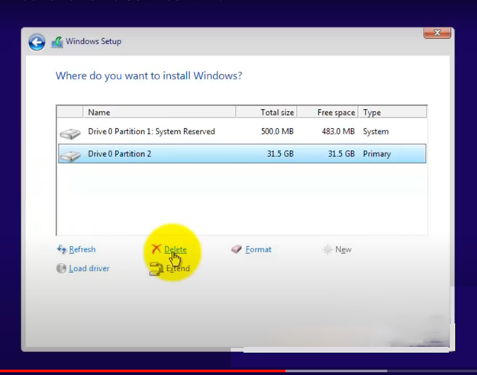

iv) Select the Disk where you want the Windows to install.

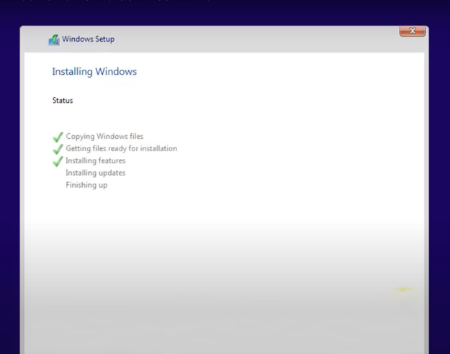

v) Wait for the installation to complete.